PHI TA KHON FESTIVAL: THE GHOSTS & GHOULS OF THAILAND

Buddhist legend tells the tale that centuries ago Prince Vessandorn (believed to be the penultimate incarnation of Buddha) returned to the village in which he was previously banished. The community was so overwhelmed and happy by his return they rushed into the streets to celebrate. In all the commotion and the excitement the noise from the crowds was so grandiose it woke the dead spirits from the forest nearby. Today the parade entices the masses every year after year with a spectacular surge of dancing spirits throughout the streets and is seemingly the Asian equivalent to Halloween.  
Phi Ta Khon is held over 3 days involving music, dance, games, fireworks and religious sermons. Every June it is held in the otherwise sleepy town of Dan Sai, North East Thailand, details are listed below.

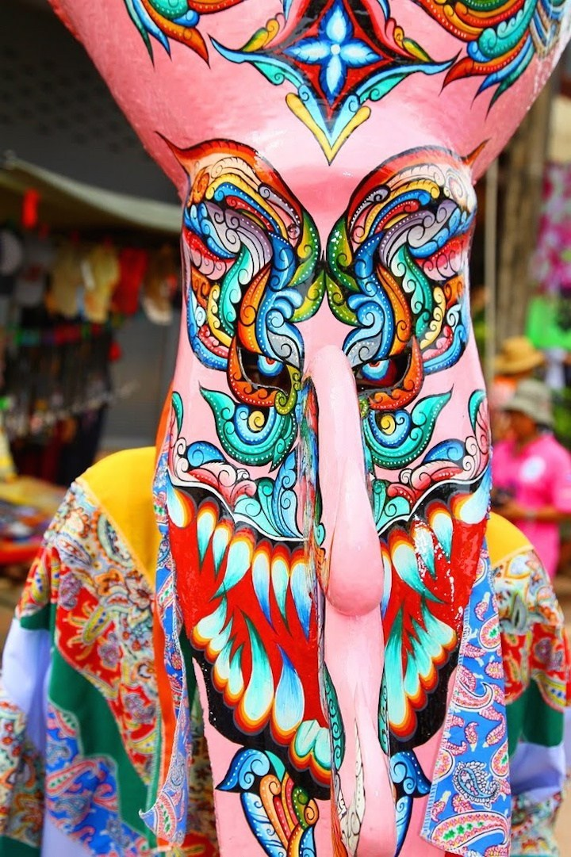

**Creepy Costumes**

Originally a children’s festival, Phi Ta Khon has gradually grown over the generations into an elaborate example of artistic ensembles. The primary focus of any costume in the festivities is the magnificent monstrous mask. Made from coconut husks and wood, the masks are deliberately hand decorated with huge protruding noses, peering evil eyes and terrifying teeth. Traditionally it was noted as bad luck to keep a mask after the festival was over and locals would instead cast them into the town’s river, but now resident artisans sell their masks to tourists for 1000s of Thai Baht each year. The costume designs themselves are often simple silhouettes focused on making the most of movement during the dances. Long strips of fabric from a vibrant concoction of multicoloured materials are either patch worked together or used for fringing decoration.

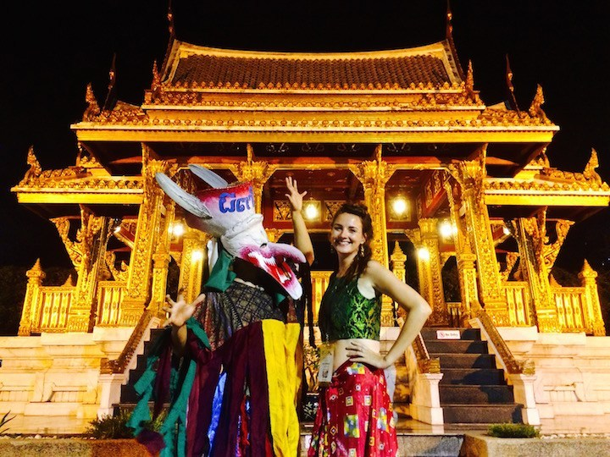  
  
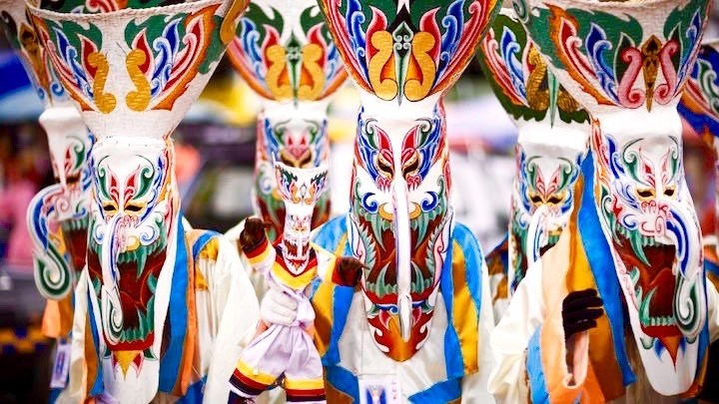

**When to go**  
The festival changes dates in June each year so it’s best to check in advance with the Thai tourist board closer to the time.